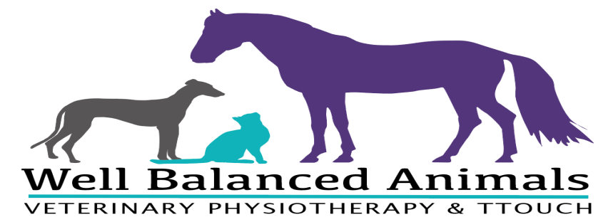
Well Balanced Animals
Rachel Jackson BA (Hons), AdvCertVPhys, PGCE, TTouch P3, Canine Acupressure, Hydrotherapy, MIRVAP, AHPR, PPG
Telephone: 0161 486 1513/07809437967
e-mail: wellbalancedanimals@gmail.com
Web: www.wellbalancedanimals-vetphysio.co.uk
Veterinary Physiotherapy Referral Form
Section A: To be completed by the owner
Name: ………………………………………………………………………………………………………………………………………………………….….
Address: …………………………………………………………………………………………………………………………………………………………
Postcode: ………………………………………………………………………………………………
Telephone:………………………………………………………………… e-mail: …………………………………………………………………………

Horse’s details
Name: ………………………………………………………………………………………………. Insured: Yes / No
Breed:……………………………………………………………………………………………….. Name of insurance company
Age: …………………………………………………………… ………………………………………………………….
Sex: …………………………………………………….…….. castrated: Yes / No
Client declaration
I declare that I am the legal owner of the horse named above. The information shown on this form is correct.
Signature: ………………………………………………………………………………………………. Date: …………………………………………………………

Referring Veterinary Surgeon To be completed by the veterinarian
Name:…………………………………………………………………………………….
Practice Address: ……………………………………………………………………………………………………………………………………………………
Postcode:……………………………………..
Telephone: ……………………………………………………… E-mail:………………………………………………………………………………………..

Details of medical condition/reason for referral: ……………………………….………………………………………………………… …………………………………………………………………………………………………………………………………………………………………………………....
Special instructions/precautions: ……………………………………………………………………………………………………………………….
……………………………………………………………………………………………………………………………………………………………………………………..
Current medication details: …………………………………………………………………………………………………………………………………..
Please include the horse’s medical history when returning this form.
Period of treatment time before this referral must be renewed:
6 months ☐ 12 months ☐ Only if new condition ☐
Veterinary Surgeon Declaration
Please accept this form as a request for Veterinary Physiotherapy treatment for the above equine. Veterinary Surgeon Declaration – “In my opinion, the animal detailed above is currently in a suitable state of health and mentation to undergo veterinary physiotherapy treatment”
Please do not hesitate to contact Rachel with any queries prior to completing this request.

Sign: ……………………………………………………………………………………………………. Date: …………………………………………….
Print name: …………………………………………………………………………………………

